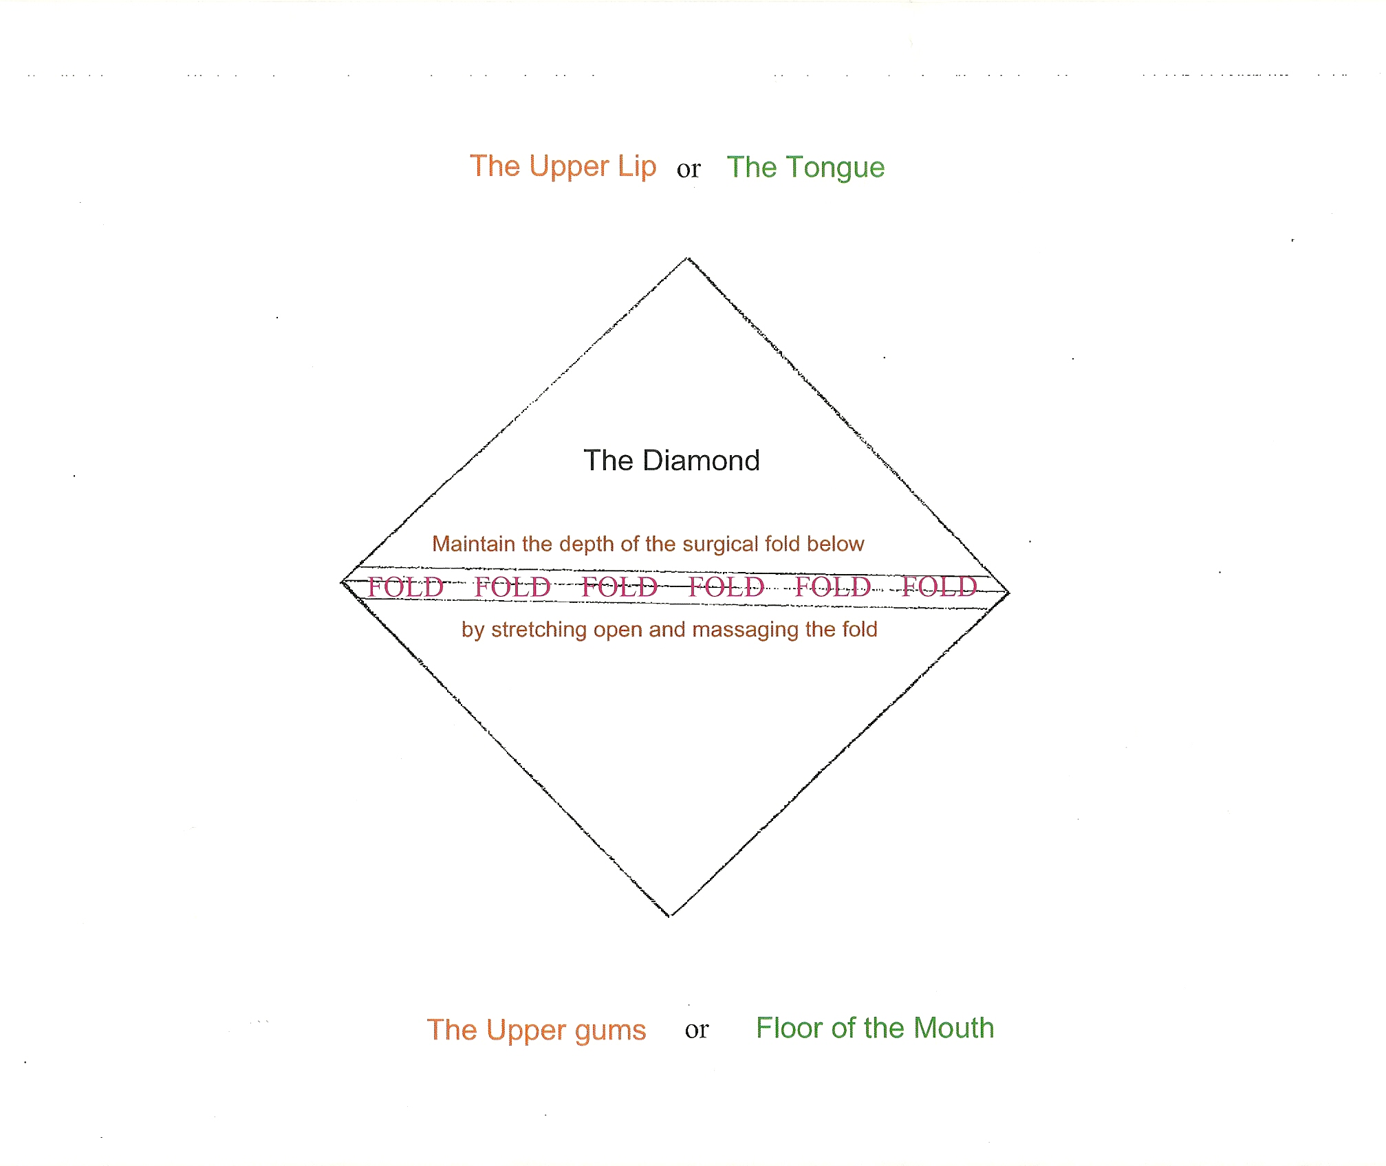

**CONTRIBUTED BY**

**Shervin Yazdi, DDS**