

**CONTRIBUTED BY**

**Shervin Yazdi, DDS**

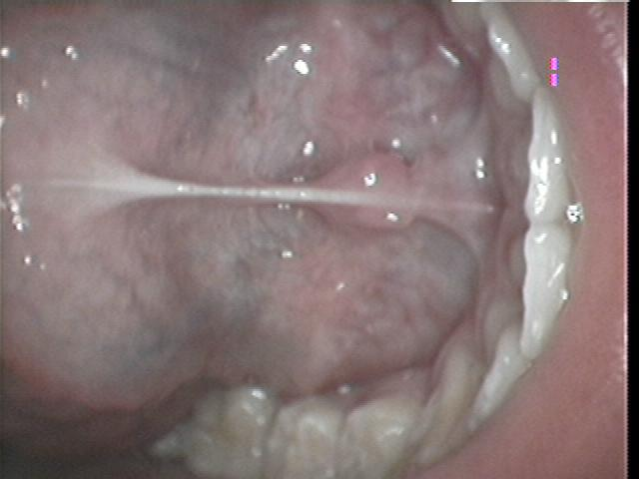**PRE-REVISION PHOTO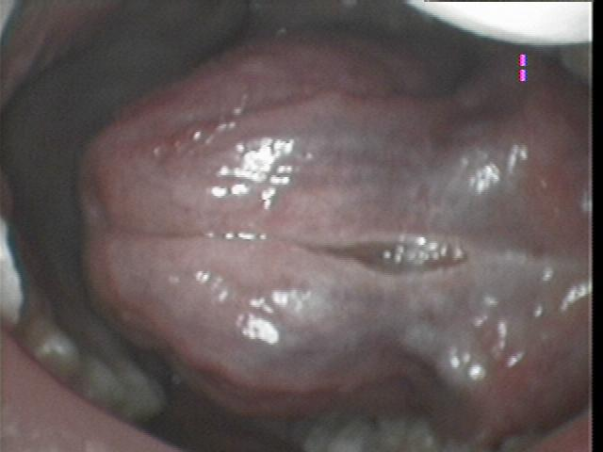POST REVISION PHOTO**