CONTRIBUTED BY
Roy D. Brewster, DDS

Phases of Wound Healing
Many wonder why frenulums grow back. One primary underlying reason is the body tenaciously and persistently attempts to close a wound it has experienced for as long as 7-12 months. Here is a synopsis on wound healing phases:
- First 3-4 days - Inflammatory Phase - Fast and Furious First Responders
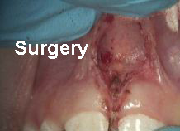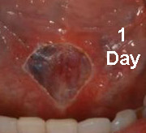  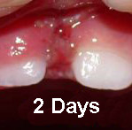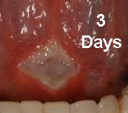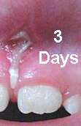 | Immediately, Tissues remaining in the wound get leaky, swell (edema) and a high protein fluid combined with water and some other chemicals form a gel that coagulates into a scab.  Within 6 hours, blood vessels and cells are proliferating and crossing the wound to close it down.  After 24 hours, small blood vessels sprout around the edge of the wound creating a pinkish-reddish appearance of the developing scar.  By Day 4, As the scar matures, capillaries stop forming and the wound develops a pale look. This “white” look is normal and IS NOT an infection.

Frenulum note: Most of this time, not enough fiber has formed to restrict the frenulum. The patient still usually enjoys the freedom of movement that the initial surgery provided.

CONTRIBUTED BY
Roy D. Brewster, DDS

- Day 4-20 - Proliferation Fibroblastic Phase - Frenulum Filament Forming Factory (FFFF)
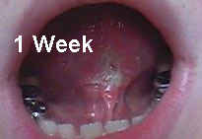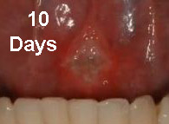  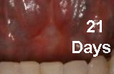  Little pain is present during stretching after a week. | An all-out attempt at wound contraction is going on. The frenulum now has a white look as the original scab has matured in to well-connected roof over “granulation tissue” that is a furnace of activity.  The next two weeks, an army of chemicals and tissue cells on missions get busy.  Of interest to the frenulum is The frenulum filament forming factory (FFFF). This is a collection of fibroblasts and accompanying vessels (blood and lymph) that spin a web of collagen that is now crisscrossing the surgical wound and attempting to close it.

Frenulum note: This is when the symptoms that existed before surgery may start to return. The frenulum is starting to re-attach itself. Stretching exercises are critical here to breakup these filaments and keep the FFFF from closing this wound and taking away the new found freedoms of the lip and/or tongue.

- Next 6-12 Months - Maturation “Remodeling” Phase
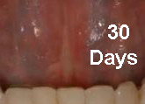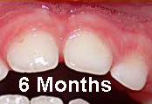  Stretching exercises are still important. | At a month, the scar has matured with no inflammation (edema/pain) present. This scar is complete with a skin (epithelial) cover now. Underneath this scar look what’s happening!  Wound contraction persists! Collagen filaments are replaced by a stronger interwoven type tissue. Granulation tissue slowly disappears, and the resulting healed tissue is a product of adaptations stresses and tensions during this phase.
Frenulum note: Stretching and supportive habits are critical here to resist the body’s persistent will to close the wound. Coupled with growth factors present in a growing child these frenulums want to close!

CONTRIBUTED BY
Roy D. Brewster, DDS

A footnote on fibrotic tissues: Emotions play a role!
“Always think of the emotional component with fibrotic patients. Preliminary results from clinical emotional therapy suggest that the more the patients feel insecure, threatened, or hopeless, the more likely they are to “armor” themselves with fibrotic tissue.”*
Frenulum note: All therapists, surgeons and teams need to promote a respectful, supportive atmosphere to give the frenulum patients best chance for successful healing.
REFERENCE:
*Silent Waves – Theory and Practice of Lymph Drainage Therapy, an Osteopathic Lymphatic Technique, 2nd Edition, Bruno Chikly, M.D., D.O. (hon) © 2001, 2002, 2004 I.H.H. Publishing. 288: 350

