CONTRIBUTED BY
Roy D. Brewster, DDS

Introduction

Thank you for having confidence in my office and staff to provide your infant’s oral health care today. It is extremely important for you to recognize the importance of following all the post-surgery exercises to make sure the final results are successful.

- Hyland’s Teething gel can be applied to the surgical site as needed after surgery.
- Tylenol or Motrin type medications can be given every four hours if needed, the usual amount would be (80mg) ¹/₄ the dosage recommended for a two year old. (infants over 1 month)
- After today’s surgery: Consult with your Lactation Consultant (IBCLC) and in many cases see a person knowledgeable in craniosacral therapy (CST) on infants, such as a pediatric chiropractor, CST, or osteopath who can aid in restoring full oral function and mobility.
Facial Massage

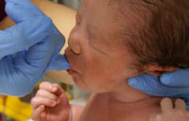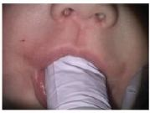

Your finger should feel pressure at the fingernail, not the knuckle during sucking.

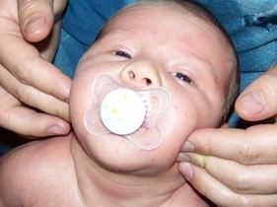

Use facial massage as often a s you want. Using your fingers will also help relax and aid your infant in learning a new sucking method.

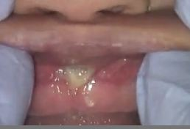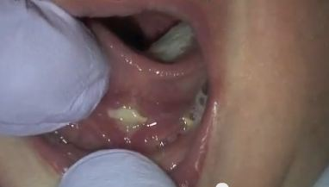

Post Surgery Appearance of the Surgical Areas

White appearing diamonds are the normal appearance 24 to 48 hours after surgery.
The white color is not any type of infection.

CONTRIBUTED BY
Roy D. Brewster, DDS

Daily Stretching Exercises

The Tongue-Tie

Stretching exercises: This is the most important part of your infant’s successful healing after I complete the surgical procedure. Failure to follow these stretching methods may lead to reattachment and the need for additional office visits and redoing the surgery if the area heals back together. Use enough force to make sure the area does not close. Begin this tonight and continue for at least 10-14 days.

TIP: (This is often easier for parents)

Reopen the surgical area by placing a tongue blade above the area and push the lower jaw down and the underside of the tongue backward and upward using sufficient force to open the entire surgical area.
Place your index fingers on each side of the tongue and forcefully open the diamond shaped area. You need to use sufficient gentle force to totally reopen the surgical site to prevent the re-attachment. Gently push or pull downward towards the infant’s throat. Some bleeding may occur and this is not a concern.
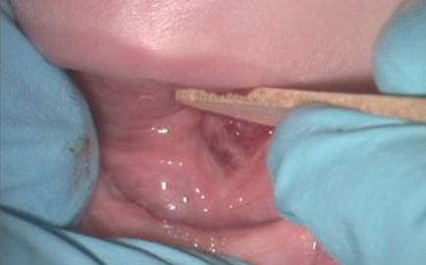

The Upper Lip-Tie

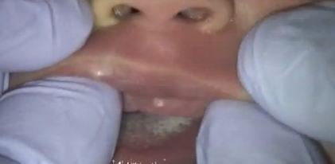
Grasping the upper lip with two hands, gently pull the upper lip upward until it touches the infant’s nose using enough force to open the entire surgical site and prevent the lip from becoming tied again.

Stretching Posture

The correct way to do stretching is with your infant’s head in your lap facing the same direction as your head.

